Tippy

jQuery Plugin Installation

Ben Capper SSD W1

Assignment One - Plugin

# **Step 1:**

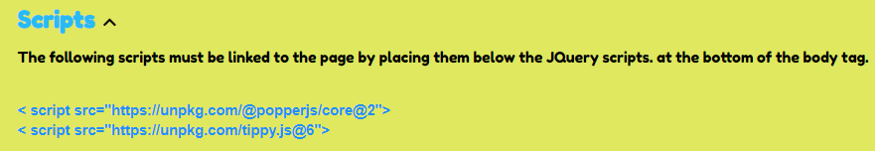

# **Step 2:**

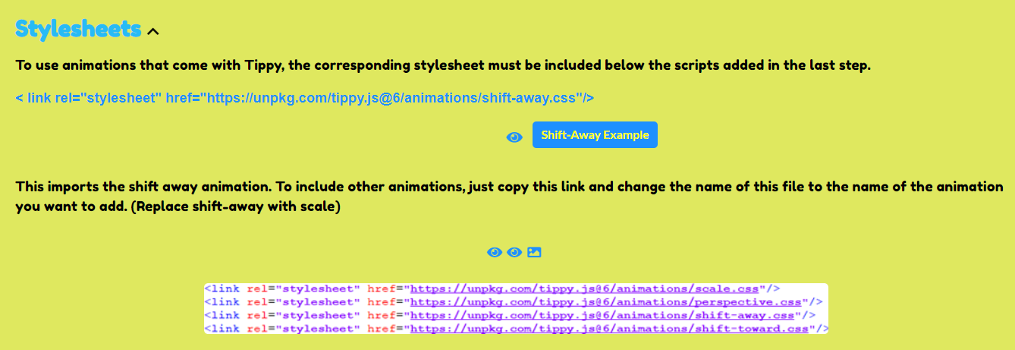

# **Step 3:**

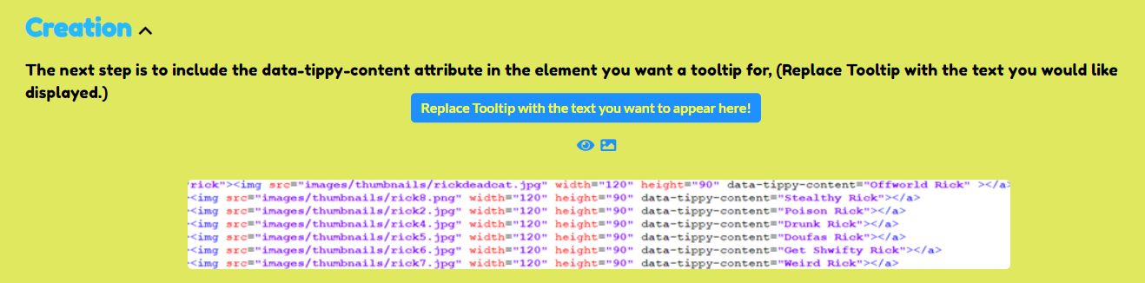

# **Step 4:**

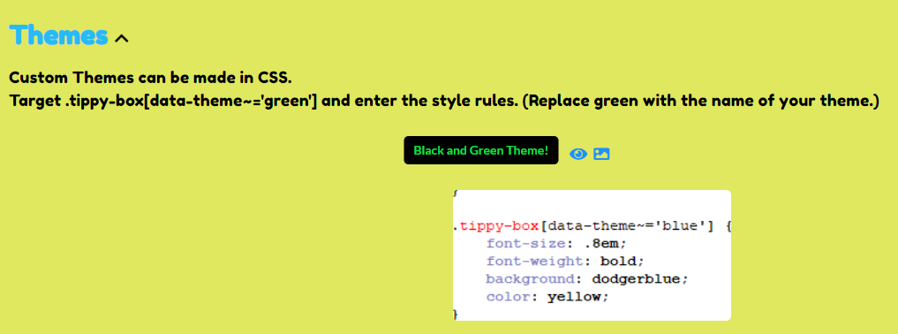

# **Step 5:**

